Account Registration
To register your account, click on the ‘Member Registration’ link and complete the fields within the registration form.
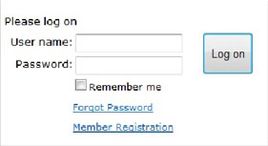
Enter your Member Number, First name and Last name exactly as they appear on your last paper statement (Note: Your First name is typically in our system as your given name). If the information entered does not exactly match that which is present in your club’s files, you will be unable to register. If you continue experiencing issues, please contact the club for assistance.
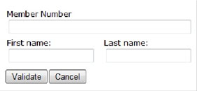
(Note: Your club may require additional fields to be completed in order for you to register your account.)
The system will validate whether the information entered is correct. You will then be taken to a page set a username and password. The system will suggest a username (the first initial of your first name and your last name, eg. The suggested Username for Steve Cowan would be scowan), but can be changed. It will ask you to enter and confirm a password of choice. Depending on your website’s settings configured by the club, there may be a specific password complexity that must be met. In the event the password is forgotten, please enter in an email address the ‘Reset Password’ link can be sent to.
Hint: If you hold your cursor over the question marks additional instructions appear.
Once all fields are filled out, click on ‘Create User’ to complete the registration process.
You will then receive a confirmation message and the Login button will be available to access the member’s portion of the website.
Example of the confirmation message:
Member Registration – Confirmation Page
User xxx has been created and registered successfully. Email has been sent to the following email address: xxx@xxx.xxx.

Logging into your Club Website
Navigate to your club’s login page by clicking on this ‘Member Login’ link, or on the link usually located in the top right-hand corner of page.
Enter the username and password you’ve created in the registration process. When finished, click on ‘Log On’.

Logging off your Club Website
It is strongly recommended to logout of the website when you are finished. Once logged into the website, the ‘Member Login’ button will change to ‘Logout’. This button will end your session and return you back to the Website Home page.

Forgotten Password
If, at some point in the future you should forget your password, you can retrieve it by clicking on the ‘Forgot Password’ link within the Member Login area. From there, you will be required to fill in the email address you provided during the registration process and click ‘Reset Password’. An email will be sent to you including a link by which you can reset your password.

